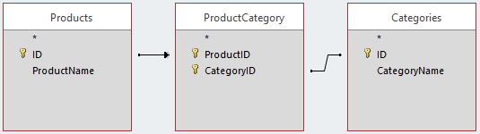

| **Products** | |
| --- | --- |
| **ID** | **ProductName** |
| 1 | Product1 |
| 2 | Product2 |
| 3 | Product3 |

| **ProductCategory** | |
| --- | --- |
| **ProductID** | **CategoryID** |
| 1 | 1 |
| 1 | 2 |
| 2 | 1 |

| **Categories** | |
| --- | --- |
| **ID** | **CategoryName** |
| 1 | Category1 |
| 2 | Category2 |

SELECT ProductName, CategoryName

FROM Products AS P

LEFT JOIN

(SELECT PC.*, CategoryName

FROM ProductCategory AS PC

INNER JOIN Categories AS C

ON PC.CategoryID = C.ID) AS PCC

ON P.ID = PCC.ProductID

